

Semester Two Examination, 2024
Question/Answer booklet

MATHEMATICS
METHODS
UNITS 3&4

If required by your examination administrator, please place your student identification label in this box
Section Two:
Calculator-assumed
WA student number: In figures

In words

Your name
Number of additional
answer booklets used
(if applicable):

Time allowed for this section
Reading time before commencing work: ten minutes
Working time: one hundred minutes

Materials required/recommended for this section
To be provided by the supervisor
This Question/Answer booklet
Formula sheet (retained from Section One)

To be provided by the candidate
Standard items: pens (blue/black preferred), pencils (including coloured), sharpener,
correction fluid/tape, eraser, ruler, highlighters

Special items: drawing instruments, templates, notes on two unfolded sheets of A4 paper, and up to three calculators, which can include scientific, graphic and Computer Algebra System (CAS) calculators, are permitted in this ATAR course examination

Important note to candidates
No other items may be taken into the examination room. It is your responsibility to ensure that you do not have any unauthorised material. If you have any unauthorised material with you, hand it to the supervisor before reading any further.

Structure of this paper

Section | Number of  questions  available | Number of  questions to  be answered | Working  time  (minutes) | Marks  available | Percentage  of  examination
Section One:  Calculator-free | 7 | 7 | 50 | 52 | 35
Section Two:  Calculator-assumed | 10 | 10 | 100 | 97 | 65
 |  |  |  | Total | 100

Instructions to candidates

1. The rules for the conduct of examinations are detailed in the school handbook. Sitting this examination implies that you agree to abide by these rules.

2. Write your answers in this Question/Answer booklet preferably using a blue/black pen.
Do not use erasable or gel pens.

3. You must be careful to confine your answers to the specific question asked and to follow any instructions that are specific to a particular question.

4. Show all your working clearly. Your working should be in sufficient detail to allow your answers to be checked readily and for marks to be awarded for reasoning. Incorrect answers given without supporting reasoning cannot be allocated any marks. For any question or part question worth more than two marks, valid working or justification is required to receive full marks. If you repeat any question, ensure that you cancel the answer you do not wish to have marked.

5. It is recommended that you do not use pencil, except in diagrams.

6. Supplementary pages for planning/continuing your answers to questions are provided at the end of this Question/Answer booklet. If you use these pages to continue an answer, indicate at the original answer where the answer is continued, i.e. give the page number.

7. The Formula sheet is not to be handed in with your Question/Answer booklet.
Section Two: Calculator-assumed 65% (97 Marks)
This section has ten questions. Answer all questions. Write your answers in the spaces provided.

Working time: 100 minutes.

Question 8 (7 marks)
The level of carbon dioxide $c$ parts per million in the atmosphere recorded by a monitoring station can be modelled by the equation $c=359e^{0.0054t}$, where $t$ years is the time since the station opened at the start of $1998$.

(a) Determine the increase in the level of carbon dioxide in the atmosphere from when the station opened to the start of the year $2024$. (2 marks)

(b) Determine the rate of growth in the level of carbon dioxide in the atmosphere at the start of the year $2024$. (2 marks)

(c) A newspaper recently quoted a claim by a scientist that the amount of nitrous oxide in the atmosphere had increased by $30\%$ in the last $30$ years to its current level of $328$ parts per billion. Use this claim and an exponential growth model of the form $n=ae^{bt}$ to predict its level in $7$ years' time. (3 marks)

Question 9 (8 marks)
A motor dealer inspected $n$ vehicles per day as part of a national vehicle safety recall, in which it was known that the proportion $p$ of vehicles have the defect. Assume that vehicles are chosen at random and that defects occur independently.

Let $X$ be the number of vehicles per day that have the fault when inspected. The mean of $X$ is $0.32$ and the standard deviation of $X$ is $0.56$.

(a) Determine the value of $n$ and the value of $p$. (3 marks)

The motor dealer also inspected $15$ vehicles per day as part of a second safety recall, in which it was known that $4\%$ of vehicles have the defect.

(b) For the second safety recall, determine the probability that

(i) no vehicles are found to have the defect in a day. (2 marks)

(ii) at least $1$ vehicle is found to have the defect in a day. (1 mark)

(iii) in a working week of $5$ days, no vehicles are found to have the defect on at least $2$ days. (2 marks)

Question 10 (7 marks)
A small body moves in a straight line so that at time $t$ seconds, $t≥0$, it has acceleration given by $a\left(t\right)=0.6t-3$ metres per second.

When $t=2$, the velocity of the body is $1.5$ metres per second.

(a) Determine an expression for the velocity $v$ of the body at time $t$. (2 marks)

The velocity of the body is a minimum when $t=t_{1}$.

(b) Determine $t_{1}$ and the velocity of the body at this time. (2 marks)

(c) Determine the distance travelled by the body between $t=0$ and $t=t_{1}$. (3 marks)

Question 11 (9 marks)
A health organisation wanted to estimate the proportion $p$ of people who support banning all additives in e-cigarettes and knew that $117$ people from a recent survey of $150$ were supportive.

(a) What feature of this sample indicates that a normal distribution can be used to model the sample proportion of supportive people? (1 mark)

(b) Use the sample to determine a $95\%$ confidence interval for $p$. (3 marks)

(c) Does this sample provide evidence that the proportion of people who support the ban has changed from an earlier figure of $73\%$? Justify your answer. (2 marks)

(d) The organisation also considered calculating a $90\%$ confidence interval. Determine the minimum sample size to ensure that the margin of error of a $90\%$ confidence interval for $p$ is at most $0.055$. (3 marks)

Question 12 (12 marks)
Two machines, A and B, are programmed to randomly dispense one of the balls they contain. Machine A contains $1$ red and $3$ blue balls, whilst Machine B contains $3$ red and $2$ blue balls. As soon as a ball is dispensed, each machine will automatically refill its container with a ball of the same colour.

(a) Determine the probability of obtaining at least $7$ red balls when Machine B dispenses a total of $8$ balls. (2 marks)

Let $X$ be the total number of blue balls when each machine dispenses a single ball.

(b) Show that $P\left(X=2\right)=\begin{matrix}3 \\ \overline{10}\end{matrix}$. (1 mark)

(c) Complete the following table to show the probability distribution of $X$. (2 marks)

$$x$$ | $$0$$ | $$1$$ | $$2$$
$$P(X=x)$$ |  |  | $$3/{10}$$

(d) Determine the mean and standard deviation of $X$. (2 marks)

Each ball dispensing machine has four moving parts and is routinely serviced. The maintenance log shows that in $19\%$ of services just one part was replaced, in $26\%$ of services three parts were replaced and the mean number of parts replaced in a service was $2.39$.

Let $Y$ be the number of parts replaced in a service.

(e) Complete the following probability distribution table for $Y$. (3 marks)

$$y$$ | $$1$$ | $$2$$ | $$3$$ | $$4$$
$$P(Y=y)$$

(f) Determine the probability that one part is replaced in a service given that fewer than four parts are replaced. (1 mark)

The specialist mechanic who replaces the parts during a service charges a call out fee of $\$115$ plus $\$75$ per part replaced.

(g) Determine the mean cost per service charged by the mechanic. (1 mark)

Question 13 (14 marks)
Let the random variable $X$ be the capacity of an AAA rechargeable battery when new. It is known that $X$ is normally distributed with a mean of $815$ mA h and a standard deviation of $15.5$ mA h.

(a) Determine the probability that a randomly selected new AAA battery

(i) has a capacity not exceeding $830$ mA h. (1 mark)

(ii) has a capacity of at least $810$ mA h given that it has a capacity not exceeding
$830$ mA h. (2 marks)

(b) Determine the capacity exceeded by $11\%$ of new AAA batteries. (1 mark)

Let the random variable $Y$ be the capacity of an AA rechargeable battery when new. $Y$ is also normally distributed but with a mean of $2067$ mA h and a standard deviation of $σ$.

(c) Use the fact that $21\%$ of AA rechargeable batteries have a capacity of greater than
$2097$ mA h to show that $σ=37.2$ mA h. (2 marks)

The random variables $X$ and $Y$ are related by the equation $Y=aX+b$.

(d) Determine the value of the constant $a$ and the value of the constant $b$. (3 marks)

Let the random variable $T$ be the time taken in minutes for an AAA battery to fully recharge when completely drained. The probability density function for $T$ is

$$f\left(t\right)=\left\{ \begin{matrix}\frac{3\sqrt{t}}{122} & 16≤t≤25 \\ \overset{ }{0} & \text{otherwise.}\end{matrix}\right.$$

(e) Determine the probability that an AAA battery recharges in exactly $20$ minutes. (1 mark)

(f) Determine $E(T)$. (2 marks)

(g) Determine $\operatorname{Var}\left(T\right)$. (2 marks)

Question 14 (15 marks)
A radio station was producing a story based on a 2011 study into zoonotic infections which found that $45\%$ of cat owners in Australia allowed their cat to jump onto their kitchen sink.

In order to check whether this proportion had changed since the original study, a researcher from the station planned to collect a new data sample by standing at the entrance to a local train station one afternoon and asking all commuters who pass by.

(a) Identify and explain two sources of bias in the researcher's sampling method. (4 marks)

The radio station decided to contract the research to a professional company, who asked the question to a random sample of $240$ Australian cat owners.

(b) Assuming that the 2011 proportion was correct,

(i) determine the probability that less than $102$ of the owners sampled allowed their cat to jump onto their kitchen sink. (3 marks)

(ii) determine, using the approximate normality of the distribution, the probability that the sample proportion of owners who allow their cat to jump onto their kitchen sink will be less than $0.425$. (3 marks)

In the original 2011 study, the confidence interval for the proportion of pet owners who allowed their dog to share their bed was $(0.2019, 0.3759)$, based on a sample of $180$ owners.

(c) Determine the number of pet owners in the sample who allowed their dog to share their bed. (2 marks)

(d) Determine the level of confidence that was used to calculate the confidence interval.
(3 marks)

Question 15 (10 marks)
The graph below shows the linear relationship between $t$ and $\log_{10}{A}$, where $A$ is the area in hectares of an algal bloom on an inland lake and $t$ is the time in hours since the area was first recorded.
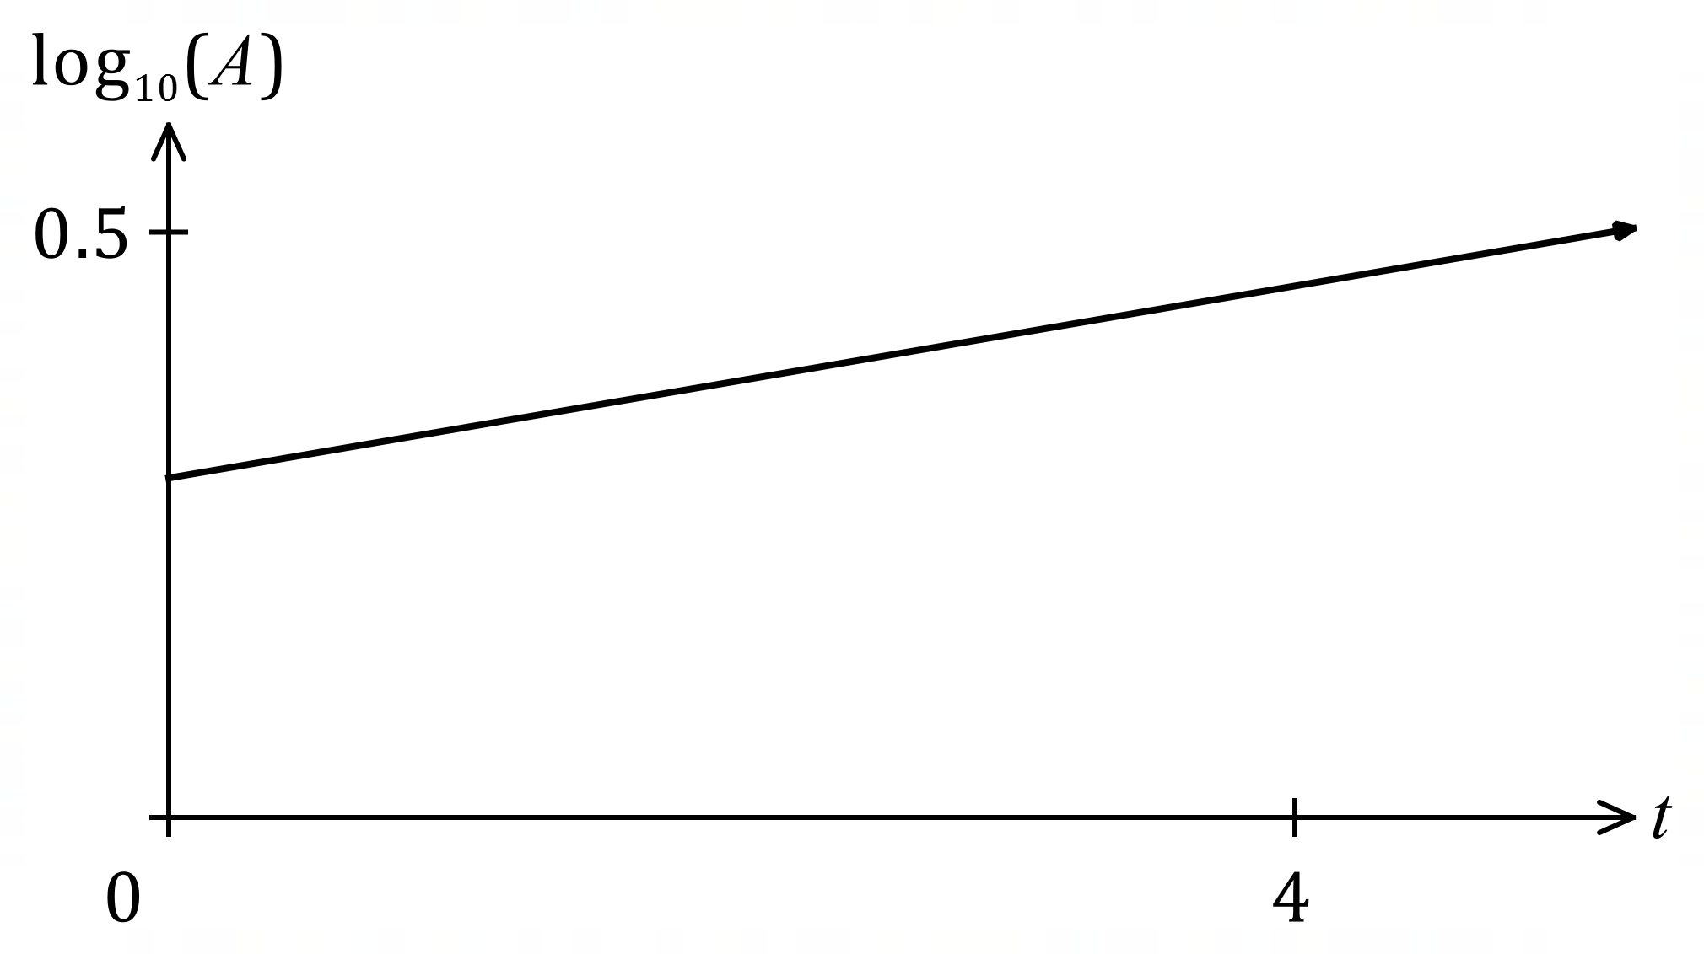

The line passes through $(1, 0.331)$ and $(5, 0.495)$.

(a) Use the two points to express $\log_{10}{A}$ as a linear function of $t$. (2 marks)

(b) Determine the area of the bloom when $t=21$. (2 marks)

The area of the bloom can be modelled by the equation $A=A_{0}r^{t}$, where $A_{0}$ and $r$ are constants.

(c) Determine the value of $A_{0}$ and the value of $r$. (3 marks)

(d) Interpret the value of $r$ in the context of the model. (1 mark)

(e) Determine the time the bloom takes to double in size. (2 marks)

Question 16 (8 marks)
The depth of water $h$ cm in a cylindrical water tank with an overall height of $135$ cm and a circular base of radius $25$ cm is increasing with time $t$ minutes, where $0≤t≤36$.

The depth of water is initially $4$ cm and changing at a rate given by $\begin{matrix}dh \\ \overline{dt}\end{matrix}=1.8\sqrt{t}-\begin{matrix}t^{2} \\ \overline{\overset{ }{120}}\end{matrix} .$

(a) At what rate is the depth of water increasing after $9$ minutes? (1 mark)

(b) Determine the volume of water in the tank after $8$ minutes. (3 marks)

(c) Determine the time, to the nearest second, when the tank will contain $200$ litres of water.
Note that $1$ litre is equal to $1000$ cm³. (4 marks)

Question 17 (7 marks)
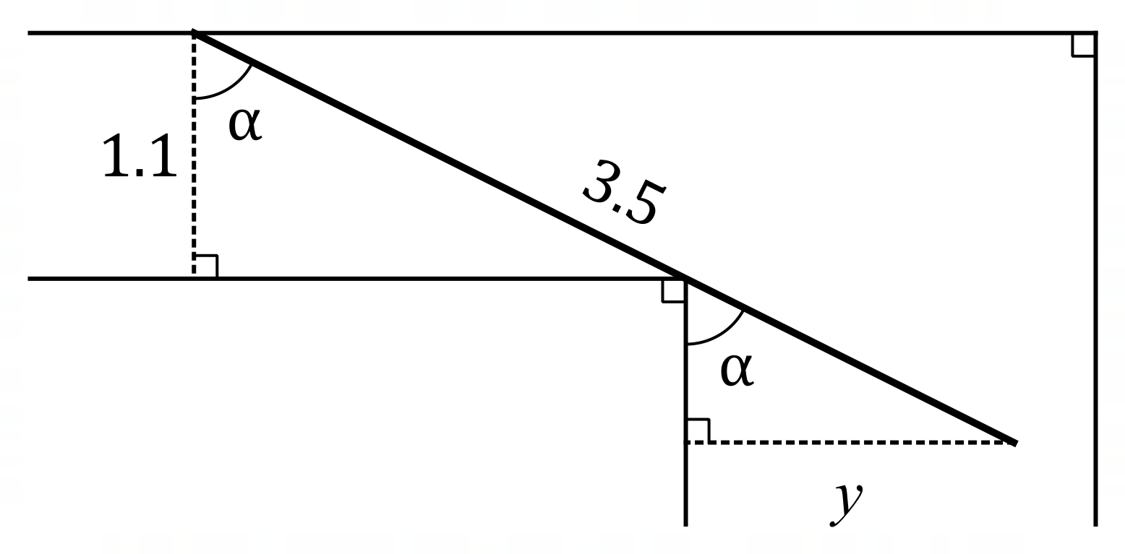
A corridor in a building is $1.1$ metres wide and meets
a second corridor at right angles. The diagram shows
a straight pipe, of length $3.5$ metres and negligible width,
being carried horizontally around, and just touching, the
corner. One end of the pipe touches the outer wall of
the first corridor and the other end protrudes $y$ metres
into the second corridor. The angle between the pipe
and the wall of the second corridor is $α$.

(a) Show that $y=3.5\sin{α}-1.1 \begin{matrix}\sin{α} \\ \overline{\overset{ }{cos}{α}}\end{matrix}$ metres. (2 marks)

(b) Use calculus to determine, with justification, the angle $α$ that maximises the distance $y$.
(4 marks)

(c) What is the minimum width of the second corridor for the pipe to pass around the corner?
(1 mark)

Supplementary page

Question number: _________

Supplementary page

Question number: _________

© 2024 WA Exam Papers. Leeming Senior High School has a non-exclusive licence to copy and communicate this document for non-commercial, educational use within the school. No other copying, communication or use is permitted without the express written permission of WA Exam Papers. SN056-245-2.

